**Maven Profiles**

**1. Introduction to Maven Profiles:**

* Maven profiles are used to **customize the build process** for different environments like development, testing, and production.
* They allow developers to **modify the configuration** without changing the main structure of the pom.xml.
* Profiles help to manage **different settings, dependencies, and plugins** based on specific conditions.

**2. Why Use Maven Profiles?**

* Profiles allow you to **build the same project differently** for different situations, like enabling or disabling tests or switching between databases.
* They help in **automating environment-specific tasks**, such as deploying to different servers or using different property files.
* You can **avoid manual changes** to the pom.xml every time you switch between environments.

**3. Where Are Profiles Defined?**

* **In pom.xml file**: These profiles are specific to the project and are used when you want the configuration to be a part of the project code.
* **In settings.xml file**: These profiles are user-specific and not shared with others; they are often used to store credentials or private repository settings.
* **Through the command line**: Temporary profiles can be activated at runtime without modifying any files, using the -P flag.

**4. Syntax of a Profile in pom.xml**

* A profile is defined inside the <profiles> tag, and each <profile> contains configuration settings.
* The <id> is used to uniquely identify and activate the profile.
* The <activation>, <properties>, and <build> tags define how the profile behaves.

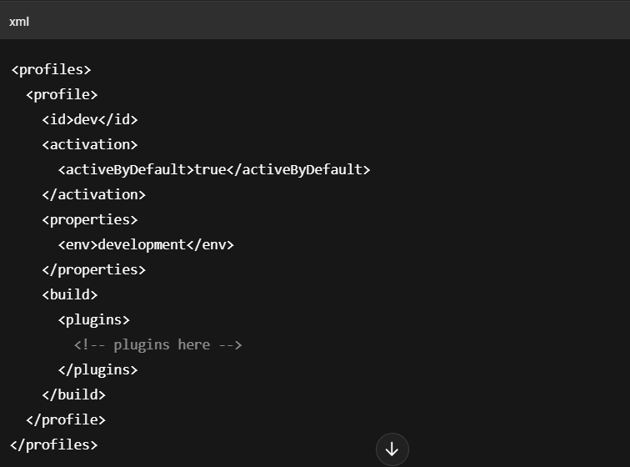

**5. Elements of a Maven Profile**

**a. <id>**

* The <id> tag is a **unique identifier** for the profile and is required.
* This ID is used when activating the profile from the command line or automatically.
* Example: <id>dev</id> creates a profile named dev.

**b. <activation>**

* This element controls **when the profile is activated** automatically.
* You can activate a profile by default, based on OS, JDK version, file existence, or system property.
* Example: Activating a profile only when a config.properties file exists.

**c. <properties>**

* Properties are used to define **custom variables** inside a profile.
* These variables can be reused throughout the POM file using the ${} syntax.
* Example: Defining a property env as development, which can be used elsewhere in the build.

**d. <dependencies>**

* This element lets you add or remove **dependencies for specific environments**.
* You can include testing libraries or debugging tools only for development.
* Reduces unnecessary dependencies in production builds.

**e. <build>**

* The <build> element allows profile-specific build configurations.
* You can define plugins, plugin executions, directories, or goals that only apply in that profile.
* Useful when using different compiler versions or output directories.

**f. <repositories>**

* Repositories can be defined per profile to **specify where Maven should download dependencies from**.
* Different profiles can point to different internal or external repositories.
* Useful when using private repositories in development and public ones in production.

**g. <pluginRepositories>**

* Similar to <repositories>, but specifically used for **build plugins**.
* You can configure where Maven downloads plugin tools for a particular profile.
* Important when your plugins are hosted in a different location than your regular dependencies.

**h. <reporting>**

* The <reporting> element is used to include **reports like JUnit, JaCoCo, or Surefire** in specific profiles.
* Helps in generating detailed reports only when needed (like during testing).
* Avoids running reports in production to save time and resources.

**6. How to Activate a Profile?**

* You can activate a profile from the command line using -P followed by the profile ID.  
  Example:  
  mvn clean install -Pdev
* You can also activate a profile automatically using the <activation> tag.
* Profiles in settings.xml can be activated globally across multiple projects.

**7. Conclusion**

Maven profiles help in **creating flexible and environment-specific builds**.  
They allow you to **define different configurations** such as dependencies, plugins, and properties,  
without modifying the core build file. This makes the project **more maintainable and professional**.